1. Create a bash script to **check if a directory is available or not.**

Step 1: create a bash file and write a script to check for a directory

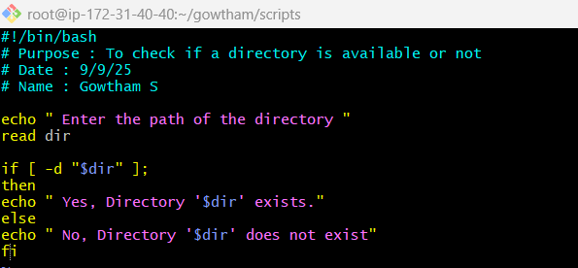

Step 2: Use **chmod 755 file.bash** to change permission and execute it

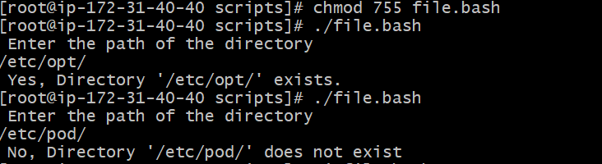

1. Create a bash script to **create multiple files**

Step 1: create a bash file and write a script to check for a directory

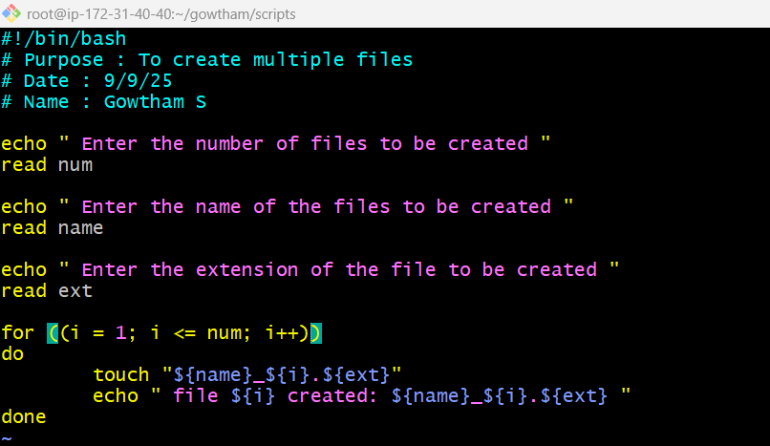

Step 2: Use **chmod 755 multi_file.bash** to change permission and execute it



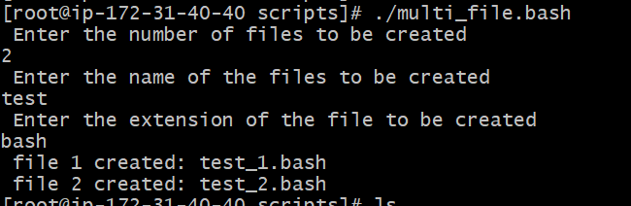

1. Create a bash script to **take a backup of a directory**.

Step 1: create a bash file and write a script to take backup of a directory

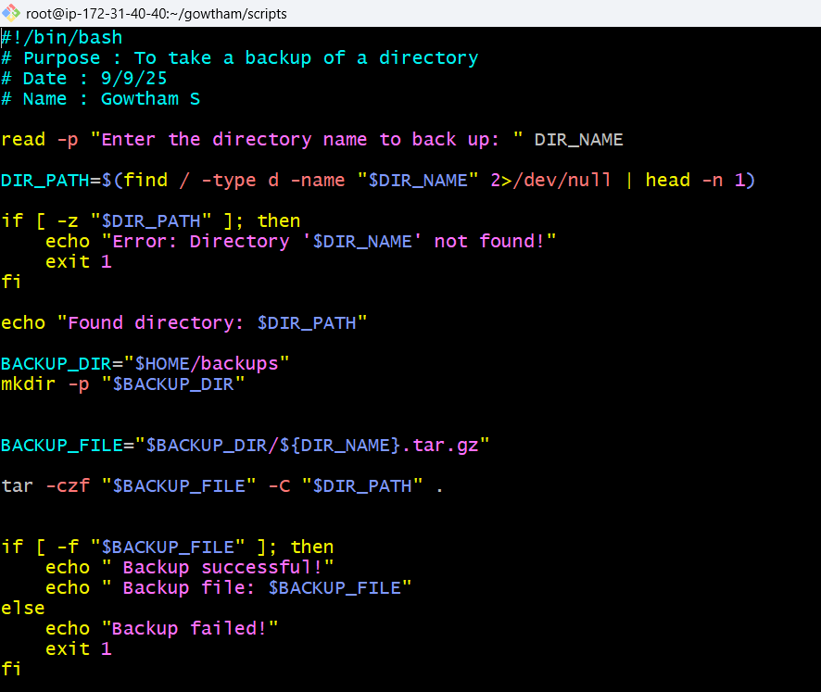

Step 2: Use **chmod 755 backup.bash** to change permission and execute it.

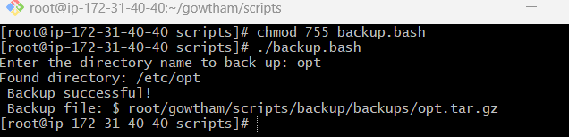

1. Create a bash script to **install Nginx on an EC2 server**.

Step 1: create a bash file and write a script to check for a directory

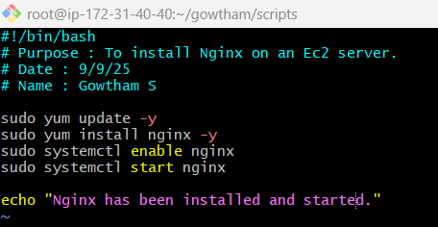

Step 2: Use **chmod 755 nginx.bash** to change permission and execute it.

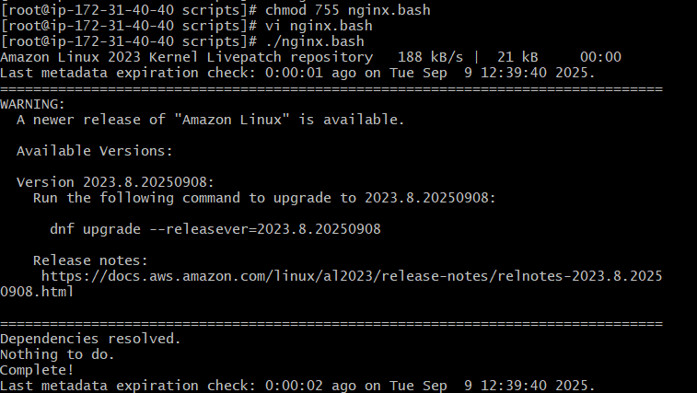

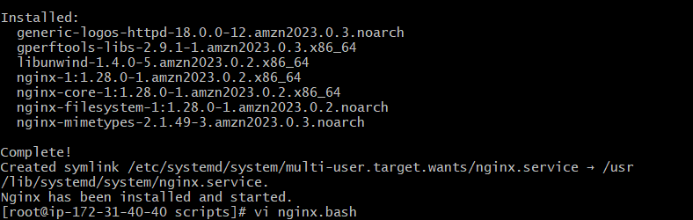

1. Create a bash script to install Apache Tomcat on an EC2 server.

Step 1: create a bash file and write a script to install Apache Tomcat

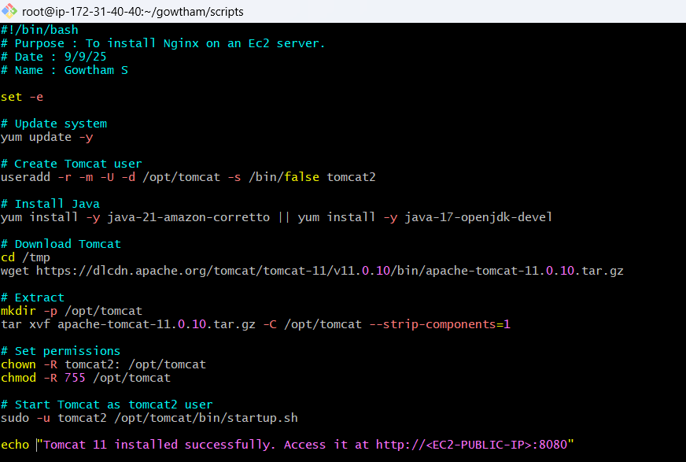

Step 2: Use **chmod 755 apache.bash** to change permission and execute it.

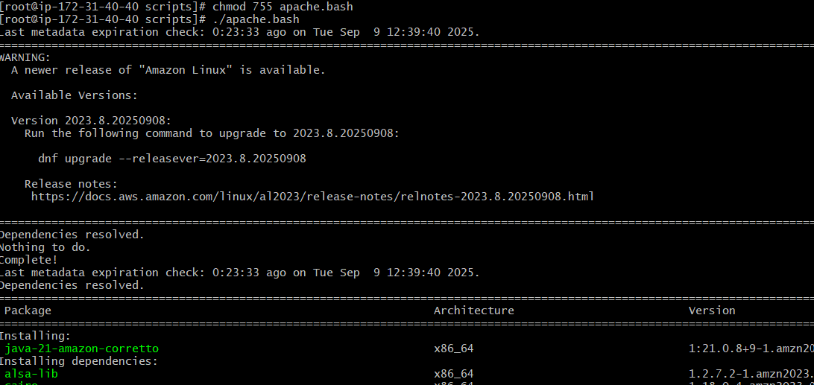

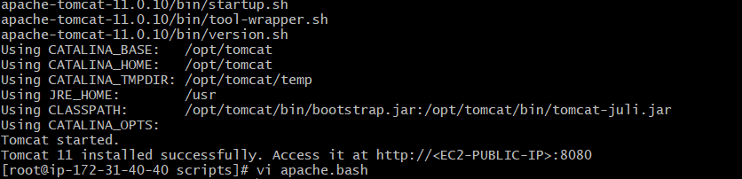

1. Create a bash script to **check if the Nginx service is running**, if not running then script should start the service.

Step 1: create a bash file and write a script to check if the Nginx service is running

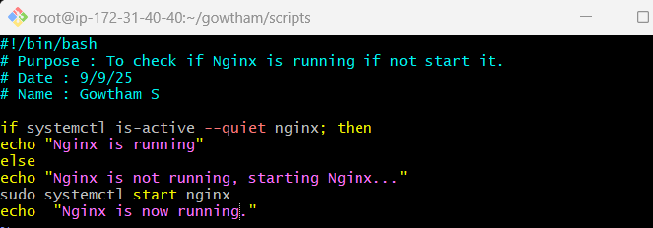

Step 2: Use **chmod 755 filename.bash** to change permission and execute it.

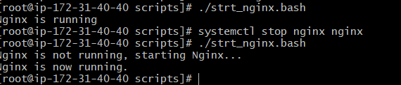

1. Create a Bash script for a calculator

Step 1: create a bash file and write a script for calculator

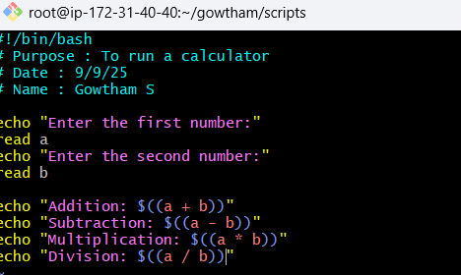

Step 2: Use **chmod 755 filename.bash** to change permission and execute it.

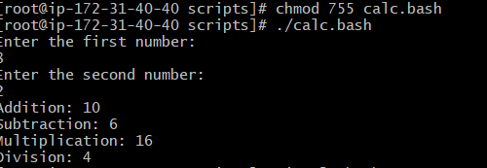

1. Create a bash script to check if the directory is available or not. If   
   not, then create a directory.

Step 1: create a bash file and write a script to check if the directory is available or not. If not, then create a directory.

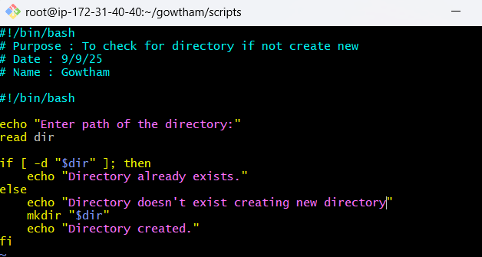

Step 2: Use **chmod 755 filename.bash** to change permission and execute it.

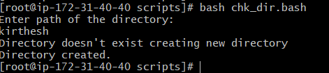

1. Create a bash script to delete last 3 lines

Step 1: create a bash file and write a script delete last 3 lines

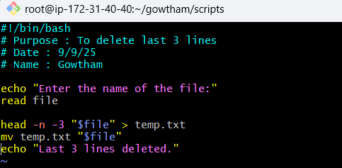

Step 2: Use **chmod 755 filename.bash** to change permission and execute it.

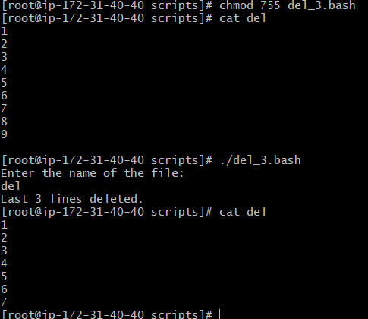

1. Create a bash script to monitor CPU. If the usage is more than 80%, then send a notification.

Step 1: create a bash file and write a script to monitor cpu

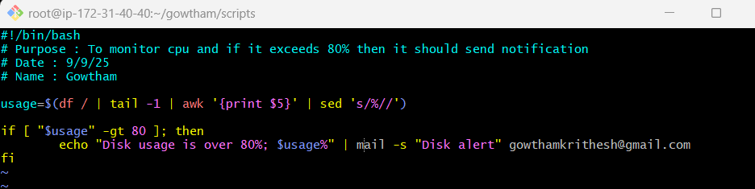

Step 2: Use **chmod 755 filename.bash** to change permission and execute it.



1. Create a bash script to monitor disk space, and if it is more than 80%,

Step 1: create a bash file and write a script to monitor disk space

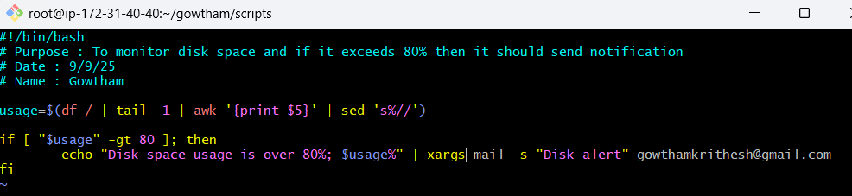

Step 2: Use **chmod 755 filename.bash** to change permission and execute it.



1. Create a bash script to monitor CPU. If the usage is more than 80%, then send a notification.

Step 1: create a bash file and write a script to monitor disk space

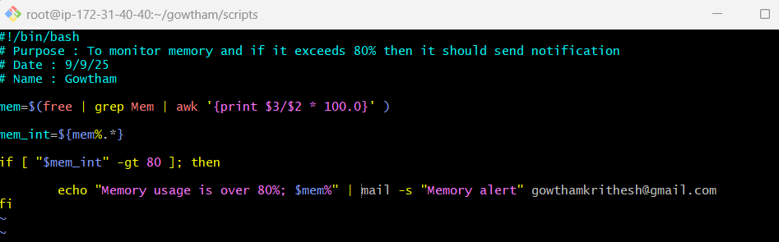

Step 2: Use **chmod 755 filename.bash** to change permission and execute it.



